Title: A delay line device for C-Band with Selective Wavelength Filtering using micro ring-resonators
Author: Priya Saini
Abstract- This work presents a photonic delay line with filtering operating in the C-band (1530–1565nm) based on an evanescent coupled micro-ring resonator structure integrated with a Y-splitter to enables coherent power division into two parallel resonator arms for interference-assisted spectral selectivity. The structure is engineered to achieve moderate to high delay appropriate for specific applications such as sensing and optical computing. Optimization is done using simulation iterations for the suitable device geometry and calculations for operating parameters i.e. coupling coefficient, lengths, round-trip time, modes propagating into the rings, loss parameters, Q factors and delay time.
- Introduction- A generic ring resonator consists of an optical waveguide looped back on itself, such that a resonance occurs when the optical path length of the resonator is exactly a whole number of wavelengths (multiple of ‘m’). Ring resonators therefore support multiple resonances and the spacing between these resonances known as the Free Spectral Range (FSR), depends on the ring radius^{[1]}. The smaller the radius is, FSR will be large which supports the idea of a delay line at specific wavelength in C-band region ^{[2]}. The transmission spectrum of the bus waveguide with ring resonator (as in AP filter) will show dips around the ring resonances, behaves as a spectral ﬁlter with significant delay, which can be used for applications in optical communication, i.e. wavelength division multiplexing (WDM), delay lines, sensing applications(gas/ liquid), optical switches, Optical computing etc^{[1]}.

- Structural Geometry and Design Parameters- In this study, micro-rings (radius<5µm) are placed at each arm of the Y-splitter for 50:50 power ratio and tuned at specific wavelengths. For this design, selected wavelengths are 1540nm & 1560nm for r₁ = 4.50µm and 1550nm for r₂ = 4.55µm. The dimensions considered in the design follow the fabrication design rules such as width=0.5um & height=0.22um. Overall, Length is calculated as per the coupling length calculations and grating couplers for the testing.
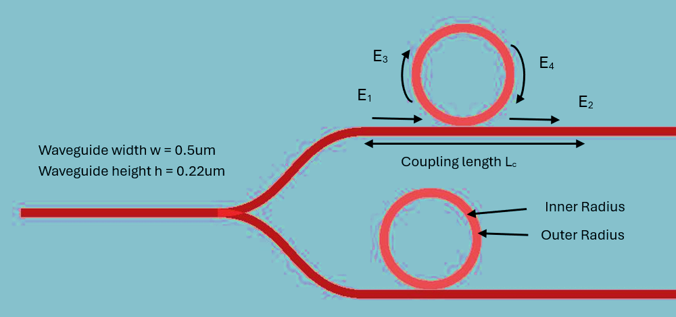
Fig.1. - Structure of the device

The formulae for coupling length L_{c}, Coupling coefficients $κ$, FSR, modal number m, are given in the Tab.- 3.1.

- Eigenmode Solver for Mode study & Key metrices- For Fundamental TE mode, eigen modes (even & odd mode) calculated by FDE Solver to calculate n_{eff,} n_{g,} at centred wavelengths 1550nm & 1540nm. Wavelengths here considered as central values for FSR~20nm for each ring. Where n_{eff} defines the values of L_{c} & $κ$, Quality factor Q & FSR depend on n_{g}. The resonant modes of the micro-rings are decided by the azimuthal mode number $m$, which represents the number of wavelengths fitting along the optical round-trip path of the ring. Resonance occurs when the accumulated one round-trip phase equals to integer multiple of $2π$. For non-integer m, the phase condition is not fulfilled, hence, prevents constructive interference and suppressing resonant energy buildup in the micro-ring. All the values with respective formulae are given in Tab.-3.1.

S. No. | Key Parameters Expression | Values calculated for  radius r₁ radius r₂ |  | Brief comment | Explanation
a. | $$m λ= n_{eff}*2πr$$  m=azimuthal mode number, $n_{eff}$= effective refractive index(even mode), $λ$=resonating wavelength, r=radius of micro-ring | 44 | 44 | Similar for both rings where central wavelengths at 1540nm & 1550nm | m defines the phase shift difference responsible for the constructive or destructive interference, further defines the overall energy intensity inside the ring
b. | $$FSR= \frac{λ^{2}}{n_{g}L}$$  FSR = Free spectral range,  $λ$ = Resonating wavelength  n_{g} = group refractive index,  L = 2$πr$: Circumference of ring | ~19.5nm | ~20.42nm | values at 1540nm & 1550nm with deviation of ±0.5nm at resonated wavelengths | as micro rings considered, FSR is high, to avoid the matched resonating wavelengths
c. | $$L_{c }= \frac{λ}{2Δn}$$  Where coupling length $L_{c }$  $Δn$= difference between n_{eff} for even and odd mode | 24.72 µm | 25.39 µm | as ring radius 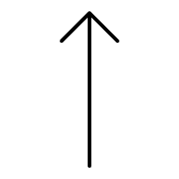  coupling length also | Length of bus waveguide for evanescent coupling for each ring
d. | $$κ= \frac{π}{2L_{c}}$$  Where $κ$ is the coupling coefficient | 0.0635 µm⁻¹ | 0.0618 µm⁻¹ | almost identical for both the rings | Weak to moderate coupling between ring and bus waveguide
e. | $$T_{rt}=\frac{n_{g}L}{c}$$  Round trip time $T_{rt}$  $L$= 2$πr$ | 0.4047ps | 0.3924ps | similar to the time-by-Time monitor 1st lobe | time taken by one round trip for each ring
f. | $$N= \frac{τ_{p}}{T_{rt}}$$  N is the number of trips through the circumference of the ring | N₁=32.8  (1537.26nm)  N₃= 51.37  (1556.78nm) | N₂=31.89  (1547.01nm) | Phase-derived delay at resonance | -
g. | $$Q_{loaded}= \frac{2πc. τ_{p}}{λ_{res}}$$  Loaded Quality factor $Q_{loaded}$  $τ_{p}$is the photon lifetime | 16083.3 (1537.26nm)  26492  (1556.78nm) | 15244  (1547.01nm) | Taken by the Q factor analysis monitor | $τ_{p1}$ = 13.12ps  $τ_{p2}$ =21.89ps  $τ_{p3}$ =12.51ps
Tab.3.1.- Key metrices for the structure, description and values calculated

- Simulations & Outcomes- To calculate the total time delay taken by the bus waveguide and for each ring & field propagations, FDTD 3D simulations were done with a mode source ranges from 1530nm to 1565nm to excite the device for a fixed time signal and to check energy & time responses of the design, frequency domain monitor at each arm for output at through-port with significant number of frequency points (500 taken) so that single wavelength would not be missed in the output plot plus a point time monitor at each arm to record the delay time for bus and ring. Q factor analysis placed inside each ring to measure the Loaded Quality factor $Q_{loaded}$ to define the intrinsic propagation and losses.
To mitigate the reflections back from the bus waveguide at the ends, the FDTD region was put with PML boundary conditions for each direction as the transmission outputs were taken at through port and not by using drop port to see the dips at resonated wavelengths by each ring. Parametric sweep for n_{eff} provided a range from 3.481 to 3.482 for better energy confinement.
Outputs by field time monitor show dips at 1537.26nm, 1547.01nm & 1556.78nm (Fig.4.2.) as which are close to 1540nm, 1550nm & 1560nm as decided for even-odd wavelength filtering with a deviation of 3nm and can be achieved by thermal tuning at each ring.
From Time monitor output, first peak shows the delay for the bus which is 0.58ps and for ring₁, first 4 lobes were considered due to noise occurrence, which gave the delay at 0.99ps, 1.39ps, 1.77ps & 2.16ps (Fig.4.1.(b)). T_{rt} calculated is similar the delay at fist lobe. As both rings are almost identical, time delay is nearly same i.e. ~2ps. To enhance the delay we can put an array of rings in CROW structure manner. Full width half maximum(FWHM) stands at average 0.6nm & 0.65nm for r₁ and 0.5nm for r_{2,} depicts a steep power scarcity at the resonance(Fig.4.1.(a)).
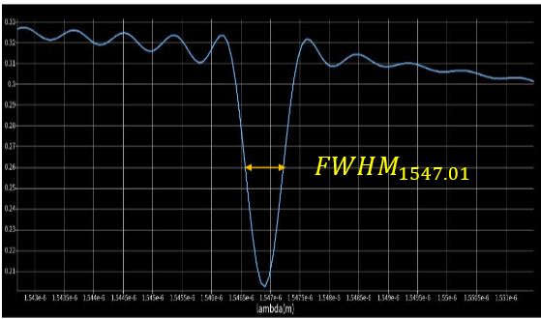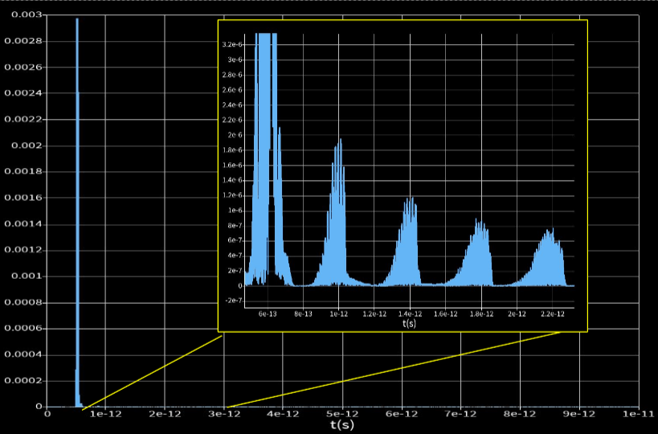
Fig. 4.1. (a) FWHM for wavelength 1547.01, (b) Time delay grpah by time point monitor showa the first bus delay followed by ring round trip delays

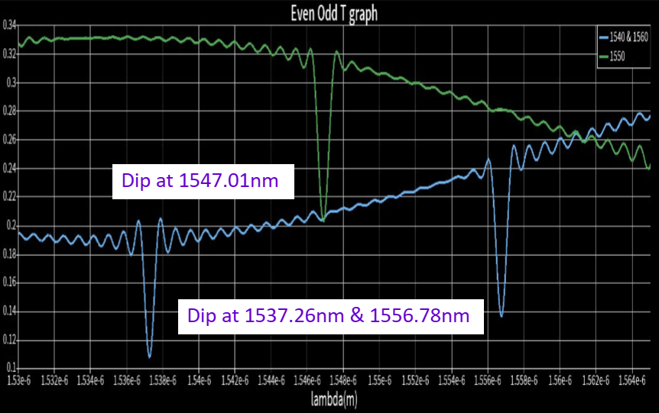
Fig.4.2.- Transmission curve combined output for both rings. Energy dips at 3 wavelengths without normalizing the T values

Loss profile for the structure can be defined as bending loss and coupling loss(intrinsic loss). For that, effective power attenuation coefficient based on Q_{loaded} is given by-
$$α= \frac{2πn_{g}}{Qλ} Np/m$$
For $λ$ = 1556.78nm, n_{g} = 4.29 with Q = 26492, effective loss is 650Np/m which is 56.8dB/cm for overall structure without considering Q_{intrinsic} and is quite high due to scattering and bending loss. Total energy decay per round trip is denoted by ‘A’ valued at 0.98.
$$A= e^{-α_{eff}L/2}$$
Extinction ratio of the device is near about 2.04dB and define by the ratio of P_{offresonance} & P_{onresonance}.
- Fabrication & Factory layout- GDSFactory with Klayout using foundry norms for DUV(248) technique and design rule kit with ±20nm margin(for Si layer) is used to prepare a .gds file for the foundry with Grating couplers VGA standard for testing purpose at both input & 2 output ports with 127µm gap, also include the 2 layer structure for Si layer and oxide layer.

Conclusion- Trade-offs are considered between moderate Q-factor and significant overall delay with filtering, demonstrates the suitability for optical buffering in comms, slow-light systems, tunable delay for phased arrays, temporary data storage for sync., filtering and sensing applications. Although the photon lifetime and peak group delay extracted from the loaded quality factor are on the single digit picoseconds, the time-domain output exhibits small to moderate delay. Extinction ratio, overall delay and low losses can be achieved by increasing the Q factor by putting heat layers on the top for the ring resonators. The current prototype stands as an infant design for both delay and filtering & can be modified by selecting the filtering criteria and number of rings with extended y splitters. The structure can be cost effective with smaller chip area and scope for further modifications.

References
[1] Bogaerts et al., “Silicon microring resonators”, Laser & Photonics Reviews, Rev. 6, No. 1, 47–73, 2012, DOI: 10.1002/lpor.201100017
[2] M. Rakib Uddin et al. “A Compact Ring Resonator Based Four Channel Multiplexer”, Developed in AIM Photonics Technology at Albany Nanotech Complex”, Frontiers in Optics.
[3] Esmail Zarezadeh et al. “Design of a novel optical delay line based on ring resonators and microcomb for beamforming in a phased array radar”, Ain Shams Engineering Journal, vol.14 p.no. 22, 2022
[4] H. Shen, J.-P. Chen, X.-W. Li, and Y.-P. Wang, “Group delay and dispersion analysis of compound high order microring resonator all-pass filter,” in Proc. SPIE 6019, *Passive Components and Fiber-Based Devices II*, Shanghai, China, Dec. 2005, Art. no. 60191M, doi: 10.1117/12.635354.
[5] T. B. R. Tejaswini and C. T. N. Chandrika, “Design and analysis of ring resonator based optical delay line,” Int. J. Innov. Res. Appl. Sci. Eng. (IJIRASE), vol. 2, no. 12, pp. 394–397, Jun. 2019, doi: 10.29027/IJIRASE.v2.i12.2019.
[6] Q. Xu, B. Schmidt, J. Shakya, and M. Lipson, “Cascaded silicon micro-ring modulators for WDM optical interconnection,” Opt. Express, vol. 14, no. 12, pp. 5358–5363, Jun. 2006, doi: 10.1364/OE.14.005358.
[7] S. A. Moiseev, “Multi resonator quantum memory with atomic ensembles,” Phys. Rev. A, vol. 113, no. 2, Feb. 2026, Art. no. 023706, doi: 10.1103/PhysRevA.113.023706

